**Understand and use number notation and place value**

**N.ME.04.01** Read and write numbers to 1,000,000; relate them to the quantities they represent; compare and order.





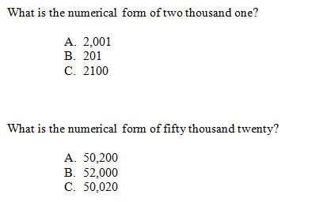

**N.ME.04.02** Compose and decompose numbers using place value to 1,000,000’s, e.g., 25,068 is 2 ten thousands, 5 thousands, 0 hundreds, 6 tens, and 8 ones.



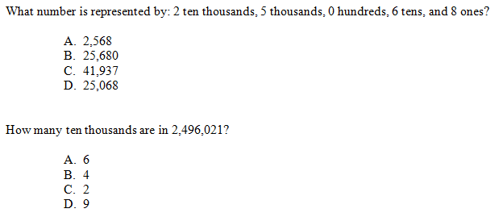

**N.ME.04.03** Understand the magnitude of numbers up to 1,000,000; recognize the place values of numbers and the relationship of each place value to the place to its right, e.g., 1,000 is 10 hundreds.





