**Measure using common tools and appropriate units**

**M.UN.04.01** Measure using common tools and select appropriate units of measure.

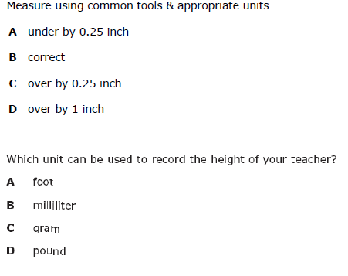

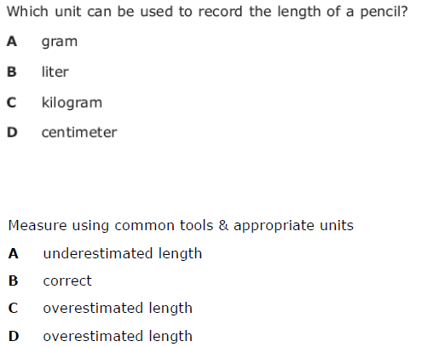

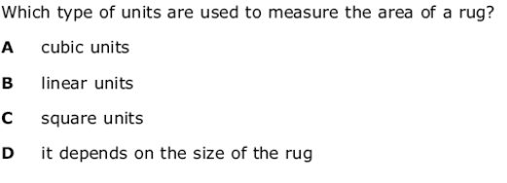

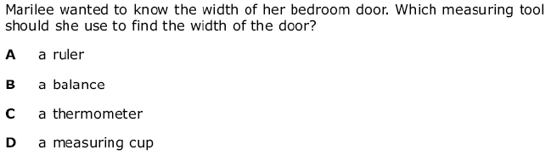

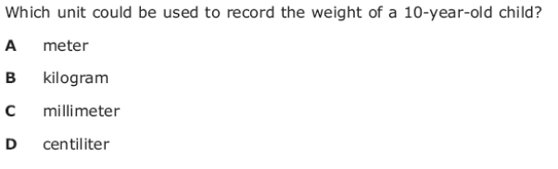

**M.PS.04.02** Give answers to a reasonable degree of precision in the context of a given problem.

