**Convert measurement units**

**M.TE.04.05** Carry out the following conversions from one unit of measure to a larger or smaller unit of measure: meters to centimeters, kilograms to grams, liters to milliliters, hours to minutes, minutes to seconds, years to months, weeks to days, feet to inches, ounces to pounds



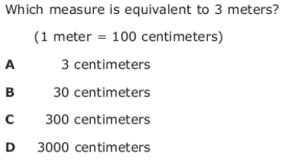

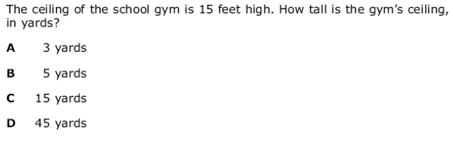

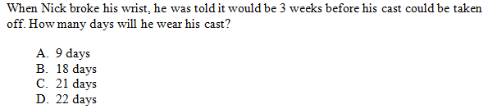

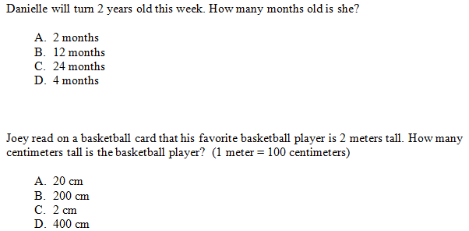

**D.RE.04.01** Construct tables and bar graphs from given data. (**WILL be on the MEAP**)





