**Add and subtract whole numbers**

**N.FL.04.08** Add and subtract whole numbers fluently.



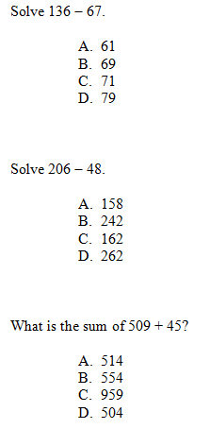

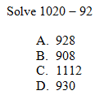

**N.FL.04.34** Estimate the answers to calculations involving addition, subtraction, or multiplication.



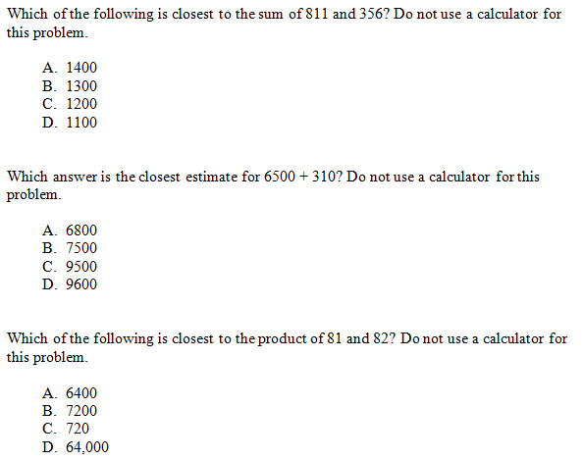

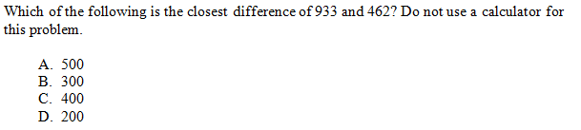

**N.FL.04.35** Know when approximation is appropriate and use it to check the reasonableness of answers; be familiar with common place-value errors in calculations.





