**Add and subtract fractions**

**N.MR.04.27** Add and subtract fractions less than 1 with denominators through 12 and/or 100, in cases where the denominators are equal or when one denominator is a multiple of the other,







**N.MR.04.28** Solve contextual problems involving sums and differences for fractions where one denominator is a multiple of the other (denominators 2 through 12, and 100).







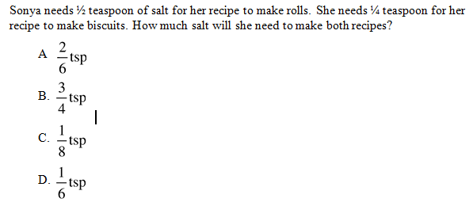

**N.MR.04.29** Find the value of an unknown in equations







